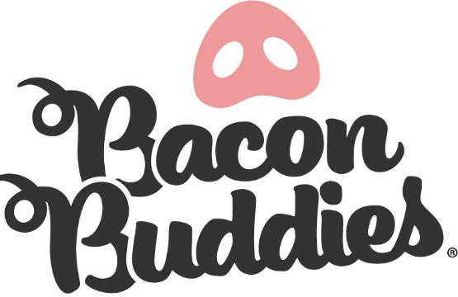
The Great Jones County Fair Bacon Buddies® Participant Application

Join us for the Bacon Buddies® Show at The Great Jones County Fair!
WHO: Persons with an intellectual and/or developmental disability, ages 5th grade - 12th grade school year (must be currently enrolled or nearing completion of 5th grade year). Each participant will be paired with a youth mentors and a pig.
WHAT: Bacon Buddies® participants will have the opportunity to experience showing a pig. The judge will assess how the mentors, participant, and pig work together as a cohesive unit. All participants will receive a ribbon, Bacon Buddies® t-shirt, and 2 admission tickets for entrance into the Jones County Fair (1 participant admission ticket, 1 chaperone admission ticket).

WHEN: Wednesday July 22, 2026
4:45 PM Participant Registration, Bacon Buddies® Participants Arrive/Connect with Youth Mentors
5:00 PM Orientation with everyone
5:15 PM Group photo, Light meal provided.
6:30 PM Bacon Buddies® Swine Show

WHERE: The Great Jones County Fair Show arena
800 N. Maple St. Monticello, IA 52310

SHOW ATTIRE: Closed toe shoes, long pants, and Bacon Buddies® T-shirt (shirt will be provided at registration) REGISTRATION DEADLINE: July 6th, 2026

PLEASE NOTE: Applicants with allergies or sensitivities shall take note that the show will take place in the Show Arena
with a sawdust floor. There are a variety of activities, lights and sounds at The Great Jones County Fair and in the Show Barn. Please bring any calming or auditory devices necessary to enhance this opportunity for your participant. Parents and/or guests are encouraged to watch the show from the bleachers and will not be allowed in the show ring during the Show.
QUESTIONS? Please email: office@greatjonescountyfair.com

Please see next pages for required consent and registration form for participants of this year’s Bacon Buddies® event. Parent/guardian is also required to complete liability waiver provided.

The Great Jones County Fair Bacon Buddies® Registration Form


Participant First & Last Name: Address: City/State/Zip: Email Address: Cell Phone: T-Shirt: Child Size: S M L XL Adult Size: S M L XL XXL
Gender: Female Male Date of Birth (Month, Day, Year): / /
School:
Hobbies/Interests:

Special Needs Information:
Dietary Intolerances/Notes for Provided Lunch: Nature of Disability: Does participant use a walker, wheelchair, or crutches? Yes, which one: No Seizures: Yes No Diabetes: Yes No
Allergies:
Parent/Legal Guardian Name(s): Address (If different from Show person): Emergency Contact Name and Cell Number: Relationship to Show person:

Submit registration form and release to:
Email: office@greatjonescountyfair.com

The Great Jones County Fair
Attn: Bacon Buddies
PO Box 150
Monticello, Iowa 52310

Please email (preferred) or mail consent and registration form. Mailed forms must be postmarked by July 6th, 2026.

The Great Jones County Fair Bacon Buddies® Parent/Guardian Liability Waiver
WAIVER TO BE COMPLETED BY PARENT OR GUARDIAN
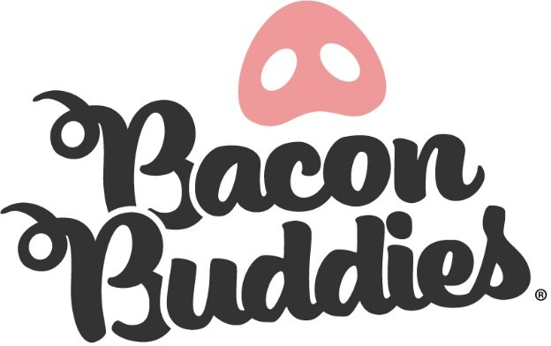
I am the parent/legal guardian of .
(participant’s first and last name)
I verify my child meets the participation requirements [Persons with an intellectual and/or developmental disability, ages 5th grade - 12th grade school year (must be currently enrolled or nearing completion of 5th grade year)] and has my permission to participate in the Jones County Fair Bacon Buddies® show.
I understand the nature of the Bacon Buddies® show and believe my child is qualified, in good health, and is mentally and physically
able to participate. I fully accept and assume all risks and responsibilities for losses, costs, and/or damages my child may incur because of his/her participation. If I, or the Bacon Buddies® show management, feel my child’s participation is unsafe at any time, I agree my child will discontinue participation immediately.
As a Jones County Fair Bacon Buddies exhibitor, I hereby acknowledge that my child’s photograph may be taken by the official Great Jones County Fair photographer for use by The Great Jones County Fair and agree to release and hold harmless the State of Iowa, The Great Jones County Fair, their officers, employees and agents and any and all parties to whom this or any photograph may be released. This photograph was taken for artistic reasons or newsworthiness, and I agree that it may be released to any medium and may be used in any manner for any purpose whatsoever without compensation.
I fully understand the animal project my child is working with is not my child’s animal and he/she is expected to care for the animal with the utmost respect.

It is understood and agreed that neither the State of Iowa nor The Great Jones County Fair shall be liable for damages.
(name of participant) does hereby release and hold harmless the State of Iowa, The Great Jones County Fair; The Jones County Fair Board; and their agents, officers and employees from any responsibility whatsoever resulting from or coming out of participation at The Great Jones County Fair by:

PRINTED NAME OF PARENT/LEGAL GUARDIAN

SIGNATURE OF PARENT/LEGAL GUARDIAN DATE

