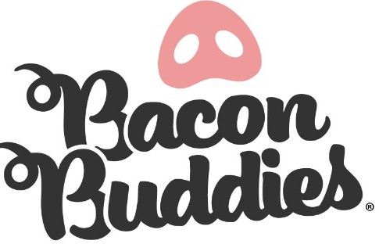
The Great Jones County Fair

Bacon Buddies® Youth Mentor

Join us for the Bacon Buddies® Show at the Great Jones County Fair!
WHO: 4-H and FFA Members will be partnered with a person with an intellectual and/or developmental disability to teach them about exhibiting a pig.
WHAT: Bacon Buddies® participants will have the opportunity to experience showing a pig. The judge will assess how the mentors, participant, and pig work together as a cohesive unit. All youth mentors will receive
a T-shirt and complimentary meal.

WHEN: Wednesday July 22, 2026
4:45 PM Participant Registration, Bacon Buddies® Participants Arrive/Connect with Youth Mentors
5:00 PM Orientation with everyone
5:15 PM Group photo, Light meal provided.
6:30 PM Bacon Buddies® Swine Show

WHERE: The Great Jones County Fair Show arena
800 N. Maple St. Monticello, IA 52310
REGISTRATION DEADLINE: July 6, 2026
EXPECTATIONS:
- 4-H/FFA youth mentor must be age 12 or older
- Actively Enrolled in 4-H or FFA
- Arrive on time and dressed in appropriate show attire, including Bacon Buddies® T-shirt
- Exhibitor will exhibit pig during the event and youth mentor will help assist and help when necessary
- Bacon Exhibitor and Mentor pairings will be assigned by Bacon Buddies® committee
- Stay for the entire Bacon Buddies® event and show QUESTIONS: Please email: office@greatjonescountyfair.com

Please see next pages for required registration form for youth mentors of this year’s Bacon Buddies® event.

The Great Jones County Fair Bacon Buddies® Youth Mentor Registration Form


Youth Mentor First & Last Name: Address: City/State/Zip: Email Address: Cell Phone: Age Grade School Possible suggestions for your Bacon Exhibitor match: T-Shirt: Child Size: S M L XL Adult Size: S M L XL XXL
Gender: Female Male
Parent/Legal Guardian Name(s):
Emergency Contact Name and Cell Number:
LIVESTOCK EXPERIENCE:
Do you have experience with exhibiting swine?
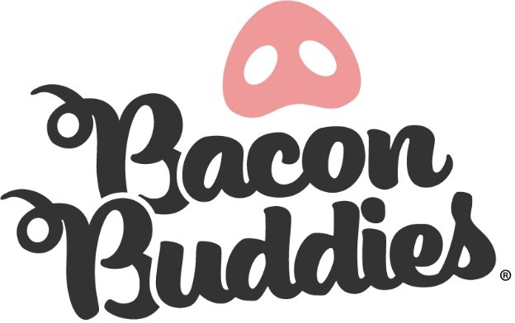
Yes No

Do you have a swine project to volunteer for this event?
Yes No

The Great Jones County Fair Bacon Buddies® Youth Mentor Volunteer Agreement
VOLUNTEER AGREEMENT:
Please read carefully, then initial next to each.
I will assist and support my participants to make their swine showing experience the best it can be.
I will be respectful, kind, and courteous to all participants, exhibitors, and volunteers.
I will be a friend to my participant (Exhibitor) and I will strive to help build confidence and self-esteem in them.
I will arrive at the swine arena by 4:30 PM on Wednesday, July 19th and stay until the conclusion of the Bacon Buddies® event.
I will wear appropriate show rings, including my Bacon Buddies® T-shirt. I will demonstrate high morals and integrity both in and out of the show ring.
I will be of good spirit, enthusiastic, and have a kind attitude towards all exhibitors, mentors, and other volunteers.
I agree to images of me to be utilized in Linn County Fair promotional materials. I agree to the conditions of this agreement, including requirements of my time.
I understand that a mentor/volunteer can be dismissed at any time by the Bacon Buddies® committee.
I agree to uphold the same standards for time, kindness, respect, and inclusivity as the participants in this event.

Youth Mentor Signature Date

Parent/Guardian Signature Date

4-H Leader/FFA Advisor Date

Submit registration form and release to:
Email: office@greatjonescountyfair.com

The Great Jones County Fair
Attn: Bacon Buddies
PO Box 150
Monticello, Iowa 52310

Please email (preferred) or mail consent and registration form. Mailed forms must be postmarked by July 6th, 2026.

